Looking into graph analytics, it involves moving data points and relationships between data points into a graph format (also known as nodes and links, or vertices and edges). (Oracle, 2020) With this method of analytics, it will allow potential queries to be in a format that allows for a larger audience to understand possible relationships within the data. In understanding the basic aspects of graph analysis, the records of a data file can be considered as the nodes while the connections between different data files, the keys, can be described as the links. With these nodes and links, you can then create edges which will then be the connections between the different nodes. On Oracle’s site, they provide an idea on how this operates compared to various tables connecting.

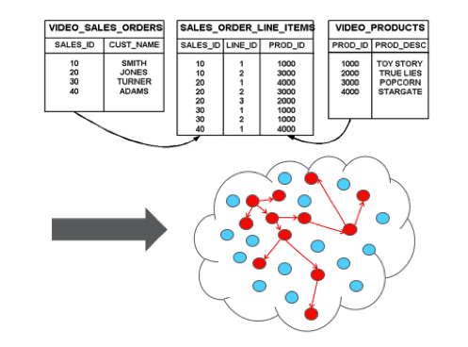

(Oracle, 2020)

In their example, the dots are the records where they all are originally blue in the beginning. When the process of querying the information is started, the records and their connections are show by the red dots and the arrows connecting them. With implementing graph analytics, you have the ability to use Property Graph Query Language rather than SQL since it is more efficient in obtaining those relationships within all of the data. In the Oracle site, they provide different aspects that use this method of analysis can aid in such as shortest path and possibly identifying the weakest points within the entire network.

In the difference between graph analysis and data visualizations, you can think as the data visualization as more at the end of the analysis while graph analysis is more towards the beginning where you are still researching and attempting to understand certain aspects of the data. Even though you can understand more through data visualizations at the end such as possible patterns, graph analysis is using these visuals to uncover hidden truths or possible relationships that you search for using different models. To better portray this idea, I believe that “The Design Squiggle” by Damian Newman describes the process that I am attempting to describe.

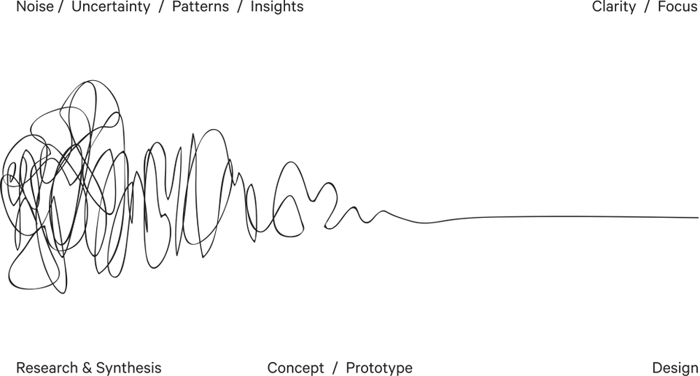

(Murray, 2019)

In this imagery, it is showing how there is more “chaos” in the beginning when you are attempting to gain a better insight on the analysis where towards the end you have more clarity and strong sense of the design for the data visualization. At the same time, a different scope of the difference would be to look at the audience for a graph analysis compared to a data visualization. For data visualizations, the audience will be those that are attempting to understand the end of the “The Design Squiggle” and be given clarity on the data that is being handled at the time. In the case of the graph analysis, the audience for these types of visuals would be those that are more focused on the “Research & Synthesis” side of “The Design Squiggle” where there any various unknowns that are to be answered in the overall picture. However, in the end, this does not mean that either are strictly designated for those areas, but it gives an understanding how these two visuals can be treated in different aspects.

References:

Murray, E. (2019, March 29). What Is The Difference Between Data Analysis And Data Visualization? Retrieved April 7, 2020, from <https://www.forbes.com/sites/evamurray/2019/03/29/what-is-the-difference-between-data-analysis-and-data-visualization/#2b34eeca6411>

Oracle. (2020). What Is Graph Analytics? Retrieved April 7, 2020, from <https://www.oracle.com/big-data/guide/what-is-graph-analytics.html#link3>

Oracle Big Data. (2018, June 19). 5 Innovative Ways to Use Graph Analytics. Retrieved April 7, 2020, from <https://medium.com/oracledevs/5-innovative-ways-to-use-graph-analytics-bacc4f2be521>

Revert, F. (2019, February 7). Getting started with graph analysis in Python with pandas and networkx. Retrieved April 7, 2020, from <https://towardsdatascience.com/getting-started-with-graph-analysis-in-python-with-pandas-and-networkx-5e2d2f82f18e>